WeShine is a non-profit organization that works with neighborhoods, businesses, and faith communities to offer hospitality rather than hostility to unsheltered through establishing transitional micro-villages on privately-owned land that WeShine leases.
Each WeShine micro-village will include six to ten tiny houses or insulated tents in a clean, safe, managed camp with:
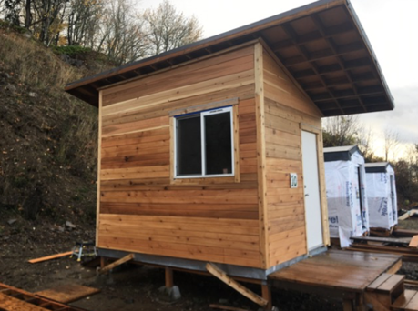
• Fencing for privacy and security
• Community structures for cooking, community meals and meetings
• Solar-powered electricity and heat in each unit
• Toilet facilities
• Garbage and recycling service
• Regular access to showers and laundry
• A Village Life Coordinator with lived experience of homelessness
WeShine will contract with local service agencies to provide mental health, addiction, and housing transition services at each site.

Neighborhood and faith-based volunteers will provide additional support, such as community meals, social and recreational activities, and encourage mutual engagement between villagers, neighbors, and congregants.

WeShine is seeking property owners who are interested in turning a portion of their parking lots into a site for one or more WeShine micro-villages.

Together, we can reduce the number of people living on the street in dirty, dangerous situations while giving campers hope, dignity, and safety as they wait for permanent affordable housing.

